Chapter 4: Implementation
4.1 Introduction
This chapter describes the implementation of UniPark Hail, the web prototype built for parking inside the University of Hail campus. It first identifies the software used to construct the system and the purpose of each tool. It then presents the features that a student, a faculty member, a staff member, or a campus-security user can operate, with a screenshot of each feature.
The implemented prototype shows the campus parking zones on one layout, gives every bay a code such as A15, and marks each bay as available, occupied, or reserved. A simulated feed records arrivals and departures, and a free bay can be sent to Google Maps. Registration, a location finder, and a timed reservation were added so that a user can sign in, find the nearest free bay, and hold that bay before arriving. The prototype does not use physical sensors, payment, barriers, or a vehicle record. These screens follow the four processes defined in the design: displaying availability, updating bay status, preparing navigation, and monitoring zone use.
4.2 Implementation Tools and Software
UniPark Hail was implemented as one Python web application. The tools below are the ones used to build and run the prototype, and each tool has a distinct job.
• Python 3 is the programming language of the server, the database operations, and the simulator.
• Flask provides the web pages, the signed-in session, the forms, and the services that supply the map and the security summary.
• SQLite stores campus users, parking zones, parking bays, occupancy events, navigation requests, reservations, and error records in one local database file.
• HTML, CSS, and JavaScript produce the Arabic, right-to-left pages and refresh the bay status without reloading the whole page.
• Leaflet and OpenStreetMap draw the campus map and place a marker on each of the four zones.
• Google Maps is opened with a directions link that carries the latitude and longitude of the selected bay. No map key is stored in the project.
• The browser location service reads the user's position. A fixed point inside the campus is provided for a demonstration when that reading is not available.
• A separate Python thread runs the simulated sensor feed, so the map and the navigation process do not create the arrival and departure events.
• Passwords are stored with PBKDF2-HMAC-SHA256 and a random salt. The registration form does not ask for a national identity number or a card number.
• The pages use the University of Hail logo, the green and gold colours of the university website, and the IBM Plex Sans Arabic typeface.
4.3 Main Features
4.3.1 Feature 1: Registration Page
The registration page creates a campus user. The user enters a full name, a university email address, an optional mobile number, and a password, then chooses one role: student, faculty member, or staff. Security and administration accounts are not created from this form. The password must be entered twice, and the account is saved only when the two entries match. The database keeps the salted hash, not the password itself. After a successful registration the user is signed in and the campus map opens. Figure 4.1 shows the empty registration form and the three steps that follow it.
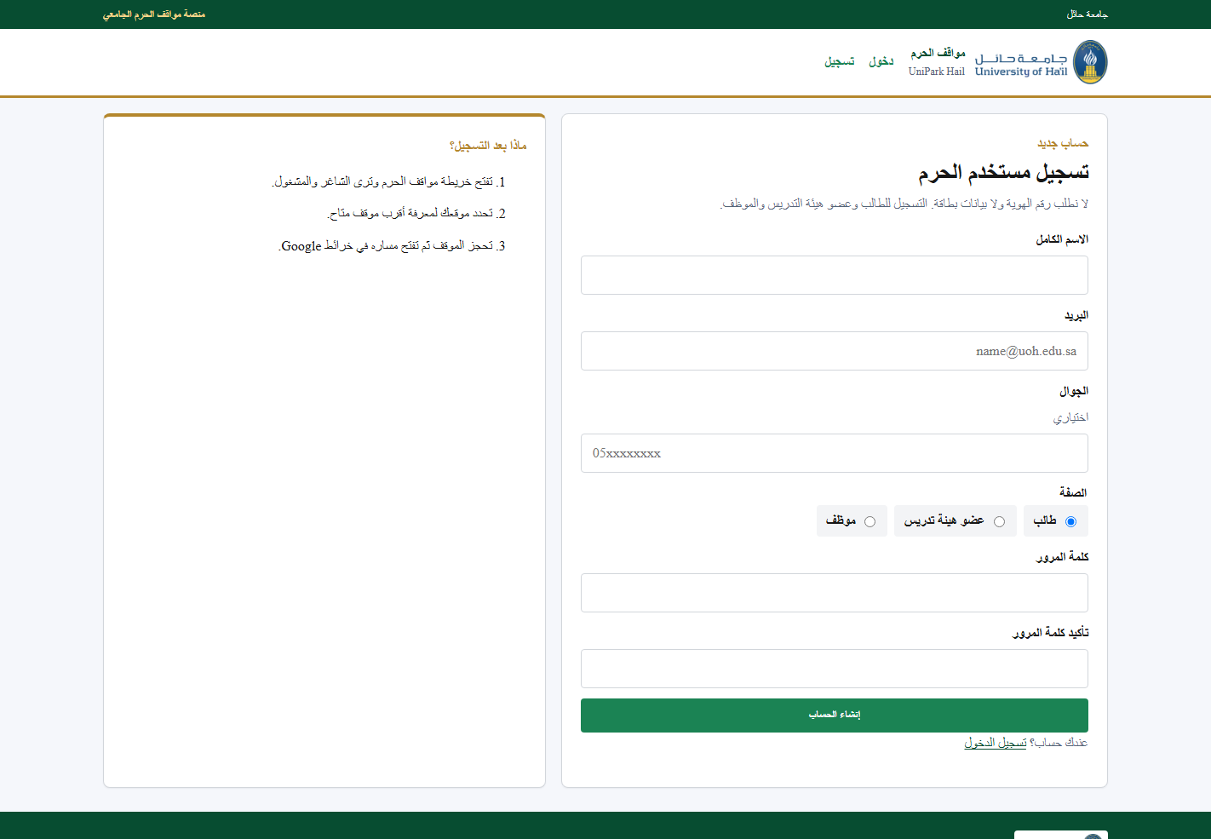
Figure 4.1: Registration Page
4.3.2 Feature 2: Login Page
The login page checks the email address and password of an existing user. A correct password opens the campus map. An incorrect password remains on the login page and does not open the parking data. Signing out clears the session. Three demonstration accounts are listed on the page, one for a student, one for a faculty member, and one for campus security, so the prototype can be presented in class. Figure 4.2 shows the login form, the University of Hail introduction, and those demonstration accounts.
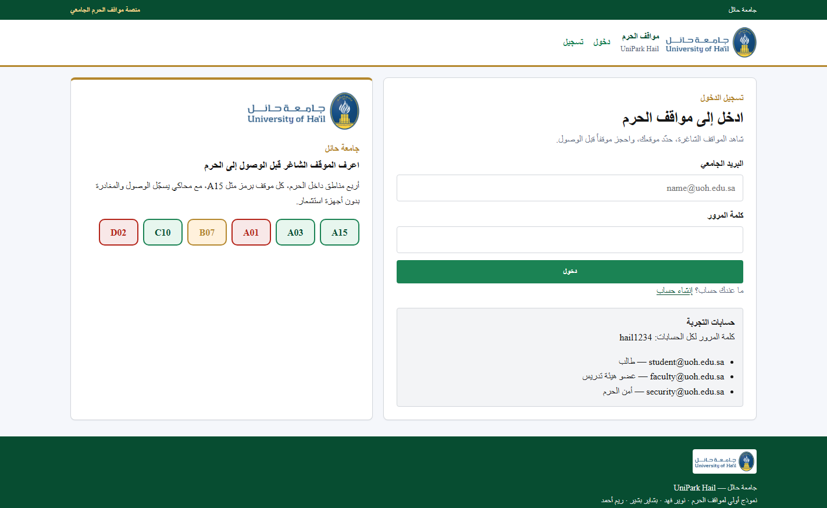
Figure 4.2: Login Page
4.3.3 Feature 3: Campus Parking Layout
The map page is the main screen after sign-in. It shows four zones inside the University of Hail: the main gate, the science colleges, the health colleges, and the faculty parking area. Every bay has its own code. Green means available, red means occupied, and gold means reserved. Each zone shows how many of its bays are still free, and that number changes when a bay changes. The same page includes a campus map with the four zone markers. The layout is read again from the server about every two seconds, and the time of the last status update remains visible. If the simulated feed stops, the last status stays on the screen with that time. Figure 4.3 shows the legend, the running feed, the location card, zone A, and the campus map.
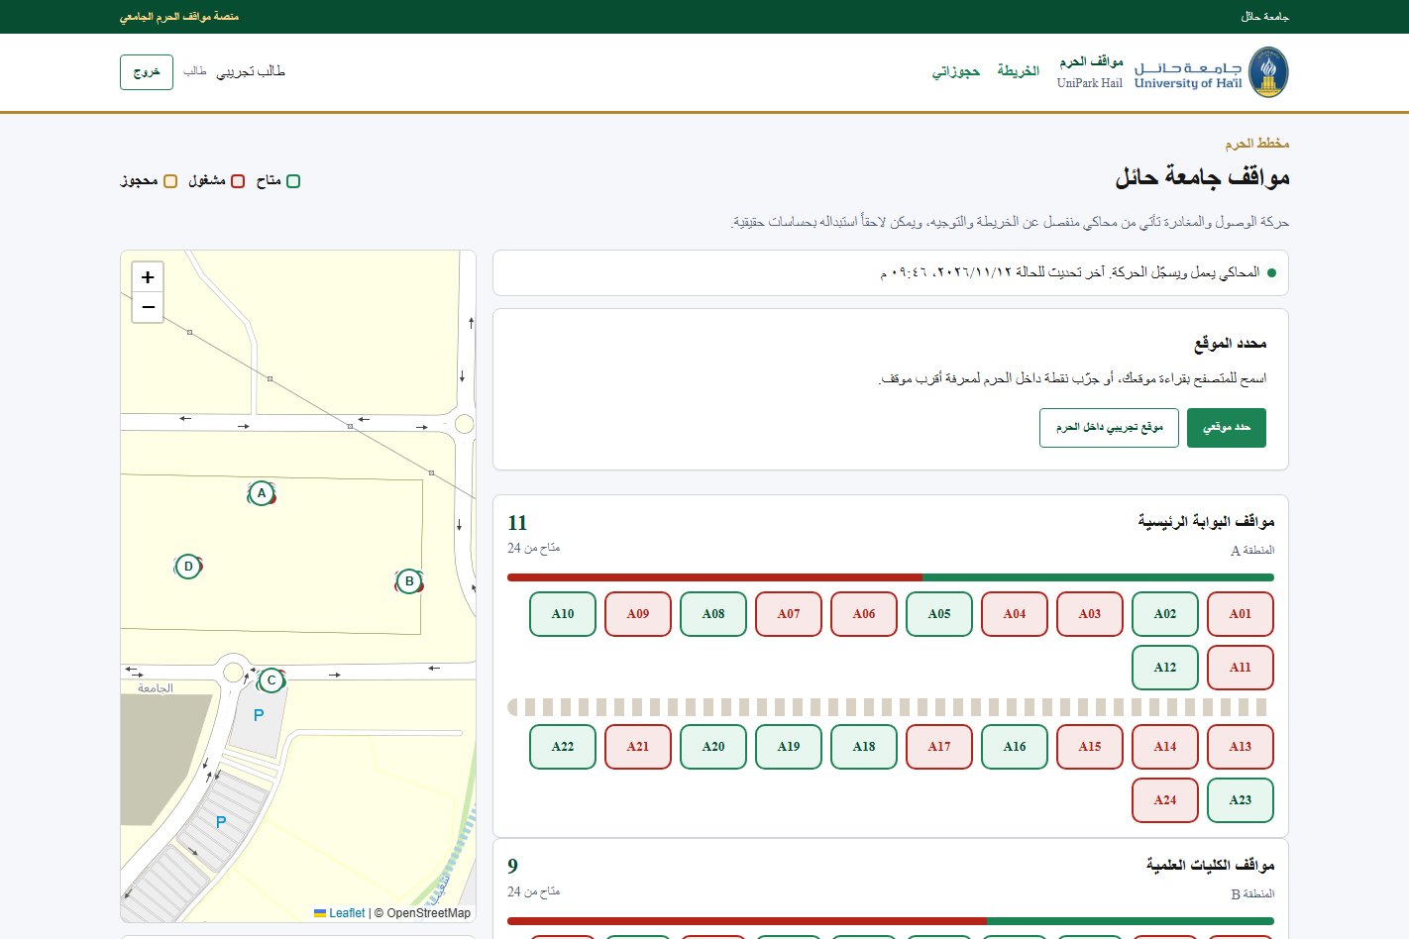
Figure 4.3: Campus Parking Layout
4.3.4 Feature 4: Location Finder
The location finder places the user on the campus and names the nearest available bay together with the distance in metres. The user may allow the browser to read the device location, or may use the demonstration point inside the campus. The distance is calculated from the user's point to the coordinates of each free bay. In Figure 4.4 the demonstration point is inside the campus, the nearest free bay is A02, and the distance is 45 metres. The same bay is outlined on the layout so the user can select it.
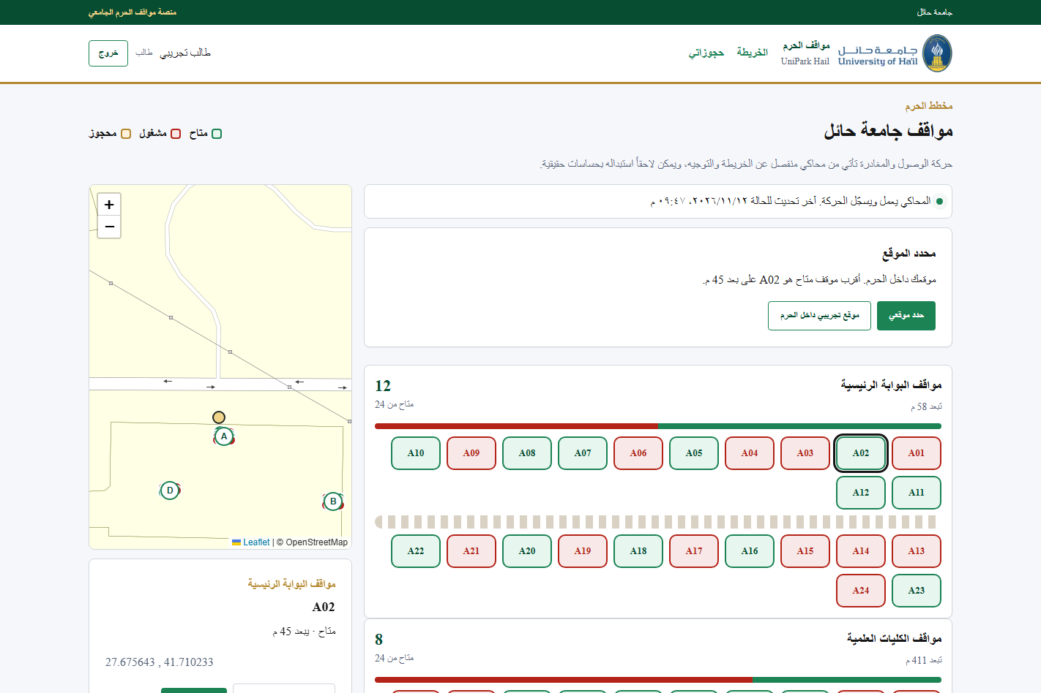
Figure 4.4: Location Finder
4.3.5 Feature 5: Navigation to Google Maps
A user can prepare navigation only for an available bay, or for a bay that the same user has reserved. An occupied bay is refused, and a bay reserved by another user is also refused. For an allowed bay the system saves a navigation request containing the user, the bay code, the time, and the coordinates, then opens Google Maps directions to that point. Figure 4.5 shows bay A02 while it is available, its coordinates, and the button labelled for Google Maps. An unknown bay code, or a bay that has no coordinates, is refused and written to the error log instead of being sent to the map.
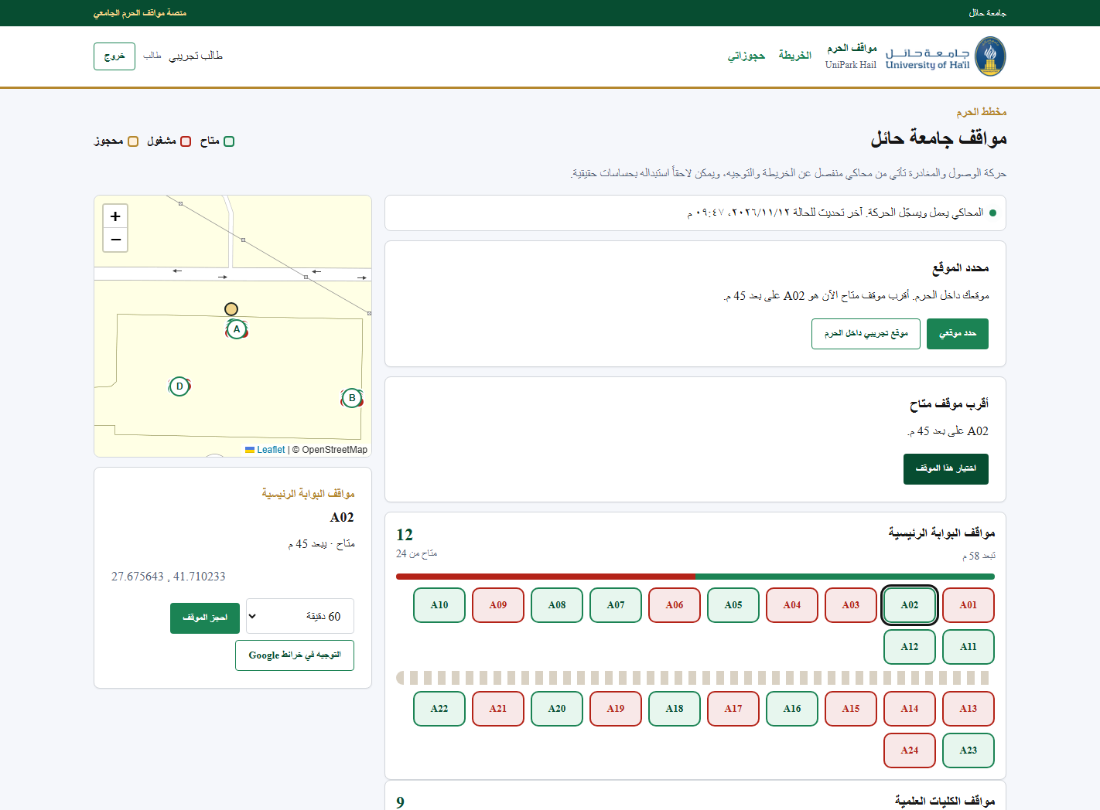
Figure 4.5: Navigation to Google Maps
4.3.6 Feature 6: Parking Reservation
A signed-in user may hold one available bay for 30, 60, or 90 minutes. The bay is then shown as reserved, and the simulator does not change it while the reservation is active. Another user cannot select it for navigation. The owner can open its route in Google Maps, confirm arrival, or cancel the reservation. When the reserved time ends, the bay returns to available. The reservations page shows the active booking and keeps the earlier bookings, including a cancelled one. Figure 4.6 shows an active reservation for bay A02 in the main-gate zone, with the route, arrival, and cancellation actions.
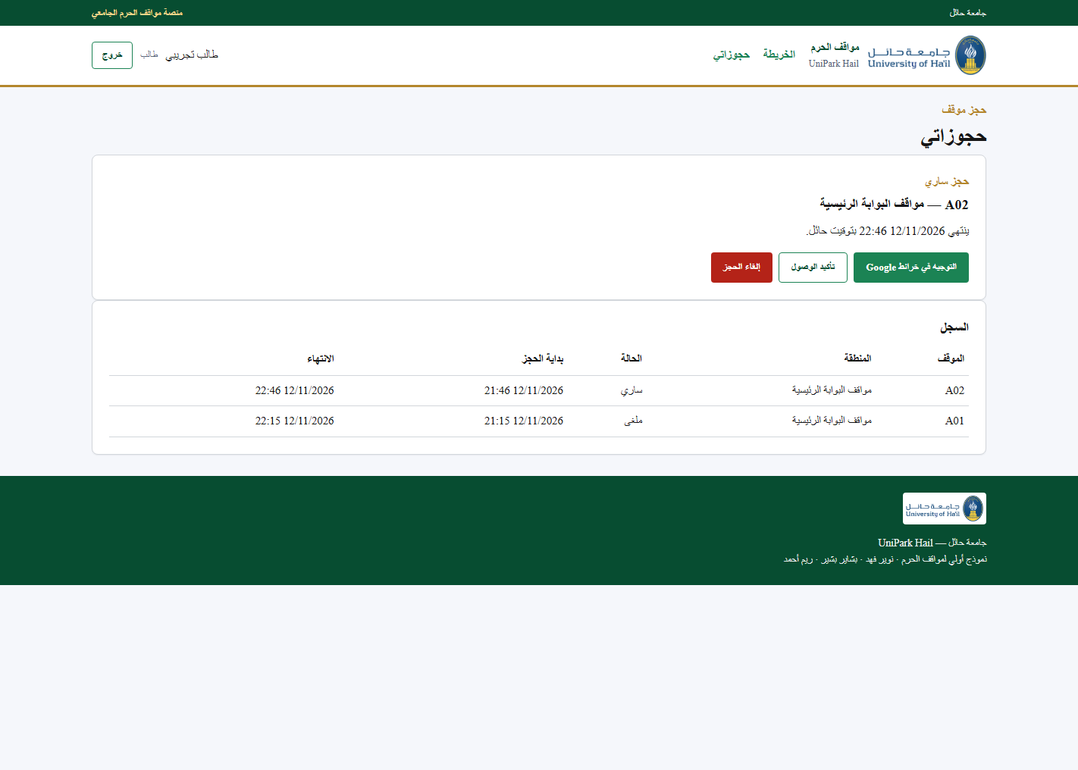
Figure 4.6: Parking Reservation
4.3.7 Feature 7: Simulated Sensor Feed
Arrivals and departures come from a simulator rather than from physical sensors. The simulator is a separate program module. On its own timer it writes an occupancy event, updates the matching bay, and recalculates the free count of that zone. It leaves a reserved bay unchanged. Campus security can start the feed, stop it, record a single movement, or submit an unknown code. An unknown code is stored in the error log and does not alter a bay. The status line in Figure 4.3 shows the feed while it is running and gives the time of the last update. Figure 4.7 shows the same controls together with the movement log.
4.3.8 Feature 8: Security Zone Summary
The security page is available only to campus security and administration. A student or a faculty member who opens its address is refused. For each zone the page shows the number of free bays, the total, the number occupied, and the number reserved. Below the totals, the movement log lists the bay, the event, the source, and the time. The navigation requests are listed on the same page, with the user, the bay, the coordinates, and the time. An error log is included for unknown codes and missing coordinates. Figure 4.7 was captured while the campus-security demonstration account was signed in. It shows the four zone totals, the simulator controls, the movement log, and the recorded navigation requests.
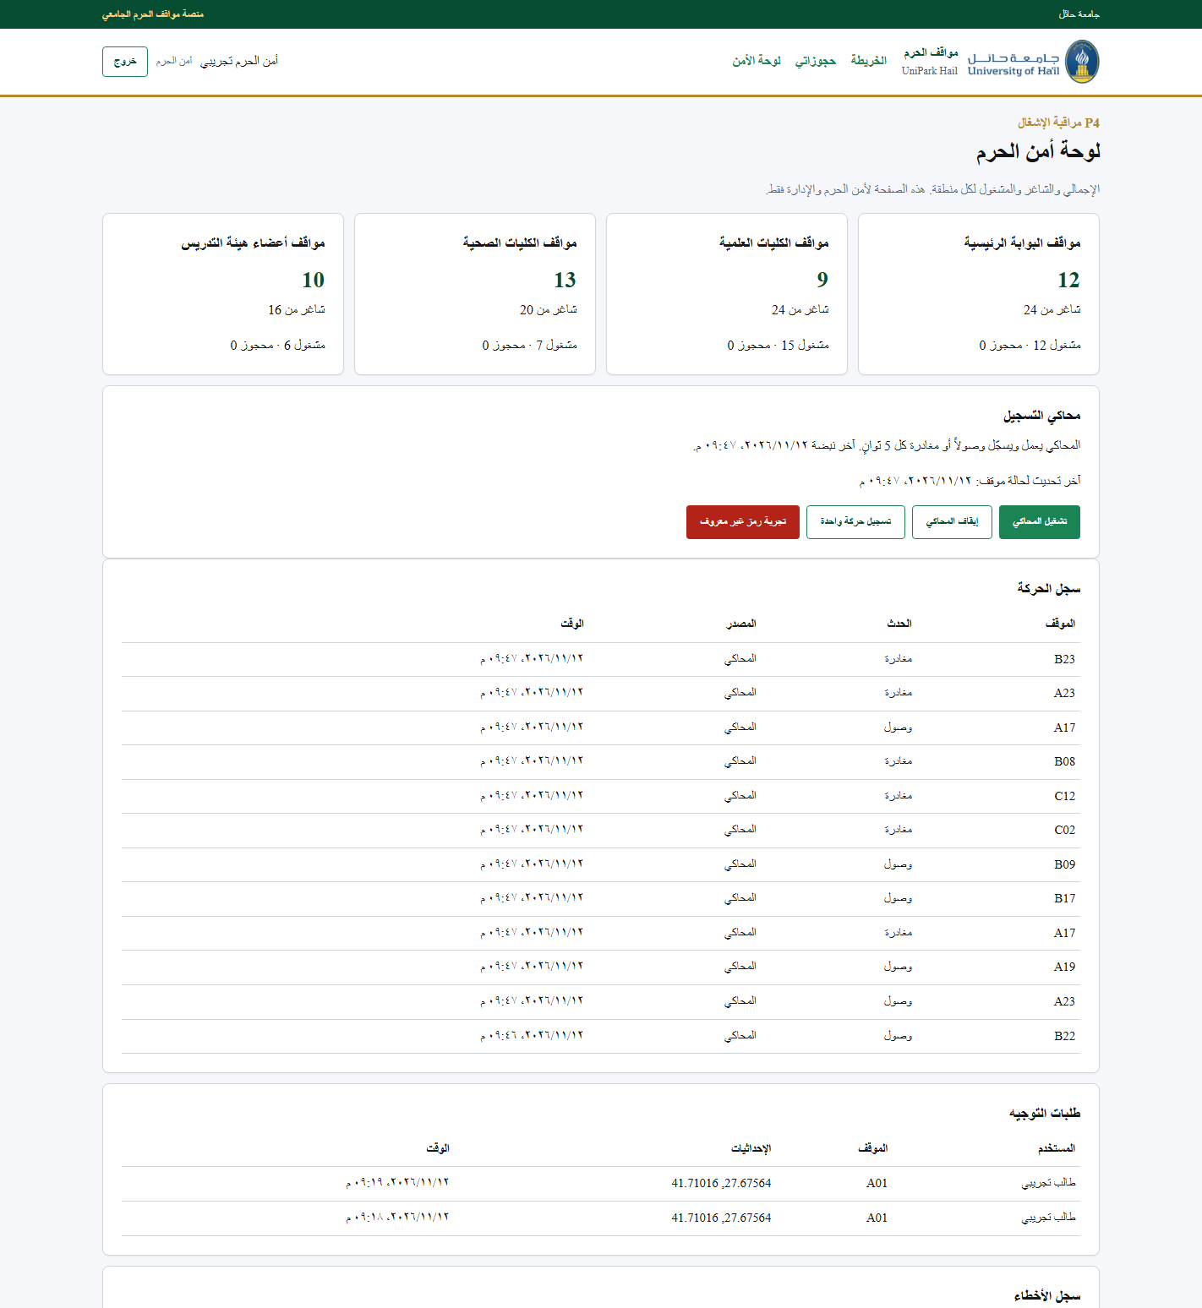
Figure 4.7: Security Zone Summary and Simulated Feed
4.4 Chapter Summary
This chapter presented the implementation of UniPark Hail. The prototype is a Python and Flask web application. SQLite stores the users, zones, bays, events, navigation requests, and reservations, while a separate simulator supplies arrivals and departures. The interface is in Arabic and follows the logo, colours, and typeface of the University of Hail website.
The features implemented in this chapter are the registration page, the login page, the campus parking layout with bay codes and free-space counters, the location finder, navigation from a free bay to Google Maps, a timed parking reservation, the simulated sensor feed, and the zone summary restricted to campus security and administration. Together these features let a campus user see a free bay, find the nearest one, hold it when needed, and open a route to it, while campus security can monitor the zones and the recorded movement.

